Software Project Management Plan
Version 1.0
May 13, 2025

Symposium Sorting System
Schedify
Brandon Tian, Project Manager
Ethan Cho, Systems Analyst
Chris Wang, Lead Programmer
Daniel Zhang, Lead Tester

Table of Contents
1.0 Introduction
1.1 Document Overview
1.2 Project Deliverables
1.3 Project Scope
1.4 References
1.5 Definitions and Acronyms
2.0 Project Organization
2.1 Process Model
2.2 Organizational Structure
2.3 External Interfaces
3.0 Managerial Process
3.1 Management Objectives and Priorities
3.2 Assumptions
3.3 Risk Management
3.4 Monitoring and Controlling Measures
4.0 Technical Process
4.1 Methods, Tools, and Techniques
4.2 Software Documentation
4.3 Project Support Functions
5.0 Schedule & Work Packages
5.1 Work Packages
5.2 Dependencies
5.3 Resource Requirements

1.0 Introduction
Every year at Poolesville High School, a symposium is held where all the seniors of the Science, Math, and Computer Science (SMCS) house present their experiences from their summer internships. The Junior Committee for the program, responsible for the creation of symposium schedules, has requested the creation of an algorithm to automate this process.

In the Poolesville SMCS Symposium project, a system must be created to generate a neat, organized table of possible presentation schedules for the senior class of students of the Science, Math, and Computer Science (SMCS) program at Poolesville High School. The system must be accessible on ChromeOS and output the possible presentation schedules based on the scheduling constraints of the seniors. This project was assigned to a group of four sophomores at Poolesville High School, MD, by the program’s Junior Committee and its sponsor, Mr. Lee.

1.1 Document Overview
This document is prepared for project team members and outlines how the project will be managed and the technical elements needed to complete the project. It is designed to support planning and scheduling activities and summarize the deliverables expected from the team.
All updates to this document are to be noted in the table below.
Version | Date | Author(s) | Notes
1.0 (Draft) | 5/13/2025 | Brandon Tian, Ethan Cho, Chris Wang, Daniel Zhang | Initial ideas and draft  Finalized first draft of SPMP
TBD | TBD | TBD | TBD
TBD | TBD | TBD | TBD

1.2 Project Deliverables
The following items will be produced by the Symposium Sorting System:
- A Software Project Management Plan outlining team organization and technical planning necessary for the creation and implementation of the Symposium Sorting System (This document).
- A System Requirements Specification document describing the requirements of the Symposium Sorting System as given by the client.
- A Test Manual reporting the test performed on the Symposium system before delivery, with compared expected and actual results.
- Source code for all systems contained in the Symposium Sorting System.

1.3 Project Scope
In-Scope (What the project will achieve):
- Develop an algorithm to generate presentation schedules based on senior students' constraints.
- Create a user-friendly GUI for accessing and viewing schedules.
- Develop software compatible with ChromeOS.
Out-of-Scope (What the project will not address):
- Manage Student registration and sign-ups for the Symposium.
- Mobile or other platform versions and compatibility (will focus mainly on ChromeOS).
- Handle room bookings.

1.4 References
Chrome incompatibilities. (n.d.). Mozilla. Retrieved May 13, 2025, from https://developer.mozilla.org/
en-US/docs/Mozilla/Add-ons/WebExtensions/Chrome_incompatibilities

Hello World. (n.d.). GitHub Docs. https://docs.github.com/en/get-started/start-your-journey/hello-world

IEEE Standard for Software Project Management Plans. (n.d.). IEEE SA. Retrieved May 13, 2025 from
https://standards.ieee.org/ieee/1058/1542/

Pal, S. K. (2018, March 18). Software Engineering | Iterative Waterfall Model - GeeksforGeeks. GeeksforGeeks. https://www.geeksforgeeks.org/software-engineering-iterative-waterfall-model/

W3Schools. (2019). PHP 5 Introduction. W3schools.com. https://www.w3schools.com/php/php_intro.asp

1.5 Definitions and Acronyms
GUI - Graphical User Interface
SRS - System Requirements Specification
SPMP - Software Project Management Plan
ChromeOS - Chromebook’s operating system
GitHub - Platform for developing, storing, managing, and sharing code that utilizes Git, an open-source version control system
SMCS - Science, Math, Computer Science, referring to the magnet program at Poolesville High School
PHS - Poolesville High School

2.0 Project Organization
The project is initiated on April 11, 2025, and terminated by the end of the school year on June 17, 2025.

2.1 Process Model
This project will follow the Iterative Waterfall Model, a modified version of the traditional, but inefficient waterfall process model. The Iterative Waterfall Model follows a structured, phase-by-phase software development process similar to the traditional Waterfall Model, but it introduces feedback paths between phases. This means if an error or a needed change is discovered in a later phase (like testing), the team can go back to earlier phases (like design or implementation) to correct it.
The main phases are:
- Requirements Gathering - Define the project goals and needs.
- Design - Plan the structure of the system based on requirements.
- Implementation - Build the system according to the design.
- Testing - Check the system to ensure it meets the requirements.
- Deployment - Make the system live or deliver it to the client.
- Review and Improvement - Evaluate performance and make enhancements in the next iteration.
These phases can be repeated as needed, allowing continuous improvement until the final product is complete.
The benefits of this model are the following:
- Errors can be detected and corrected quickly, reducing delays.
- Constant collaboration and testing reduce the likelihood of costly errors.
- New platforms that the programmer must learn can be tackled in small steps.

2.2 Organizational Structure
The contributions of each team member in this project will be almost equal. Each member is expected to be mostly responsible for their role’s corresponding documentation. However, all members of the team must work on other documentation and programming the software as well.
The general hierarchy of the project team is shown in the figure below.
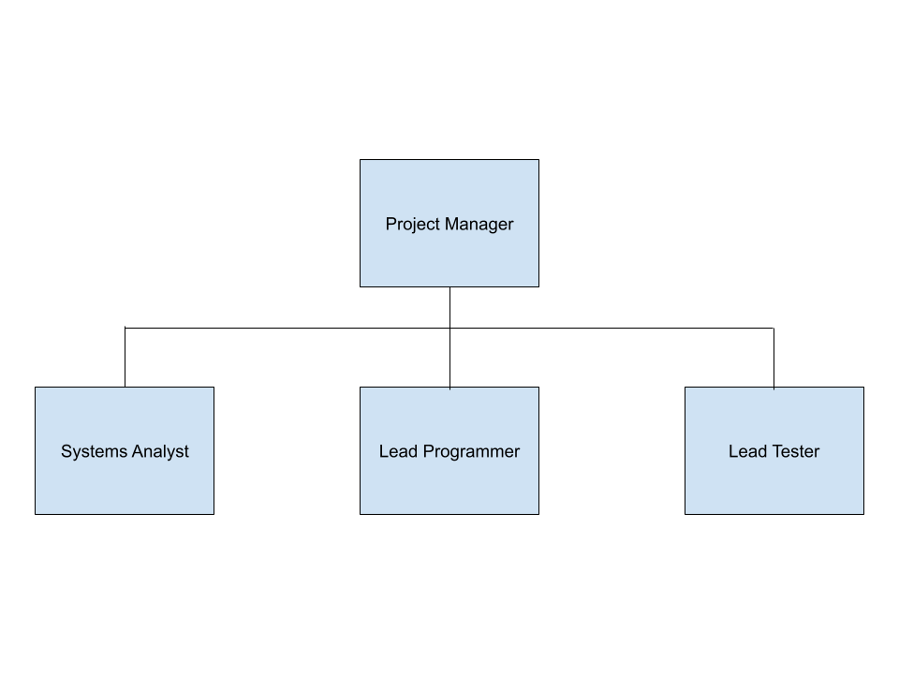
The clients of the Symposium Sorting System project are Mr. Lee and the SMCS Junior Committee. Each team member’s name, role, and job description are shown in the table below.
Name | Role | Job Description
Brandon Tian | Project Manager | Oversees the planning and execution of the project. Manages communication with the client.
Ethan Cho | Systems Analyst | Focuses on the design, development, and maintenance of software systems.
Chris Wang | Lead Programmer | Responsible for constructing all systems and subsystems within the project.
Daniel Zhang | Lead Tester | Coordinates with the Lead Programmer to execute tests, ensuring software quality and functionality.

2.3 External Interfaces
Our primary external interface is the client, Mr. Lee, and the SMCS Junior Committee that works under him. We will communicate with the client and Junior Committee members through company email, and meet in person when necessary. Ongoing communication will be essential to keep us on track throughout the project. We may also consult our technical advisor/instructor, Mr. Estep, by sharing our technical documentation with him, which he may offer feedback on.

3.0 Managerial Process

3.1 Management Objectives and Priorities
The primary priority is to develop the scheduling algorithm that adheres to certain constraints and datasets that the seniors will provide. Core functionality will be prioritized, and additional supplementary features such as matching and displaying Seniors to corresponding Juniors or graphical user interface (GUI) enhancements will be implemented later.
The key objectives of this project, listed in order of priority (starting from top priority), are as follows:
- Scheduling Algorithm with Constraint Settings
  - Generate portable presentation schedules based on individual student constraints.
- Data Interpretation Module
  - Accurate software processing and interpretation of input data.
- ChromeOS Compatible
  - Making sure that the software is accessible and functional on ChromeOS devices.
- Graphical User Interface
  - Inclusion of an intuitive and user-friendly interface.
- Additional Features
  - Additional features may be added based on further communication with the client, such as linking seniors to the corresponding juniors who will introduce them at the beginning of their presentations.

3.2 Assumptions
The following assumptions have been made during the planning of the Symposium Sorting System project:
- Availability of Constraint Data
  - All senior students will submit their presentation availability and any special constraints before the schedule generation process begins. The format of this data will be standardized and accessible (e.g., spreadsheet or form).
- Stable Requirements
  - The primary functional requirements (such as schedule generation based on constraints and ChromeOS compatibility) will remain stable for the duration of the project. Any changes will be communicated clearly and early by the client.
- ChromeOS Compatibility
  - The final software will be deployed and used on devices running ChromeOS. We assume access to devices for testing compatibility throughout development.
- No Integration with Existing Systems
  - The system does not need to integrate with other PHS databases or registration platforms. All necessary input will be provided.

3.3 Risk Management
Risk management is essential to ensure the successful completion of the Symposium Sorting System project. This section identifies potential risks that could impact the project's timeline, quality, or deliverables. For each risk, we assess its likelihood and potential impact, and outline contingency plans to minimize disruption. By planning ahead for these risks, the team will be able to respond quickly and efficiently to challenges during development. If there is a situation that requires immediate attention, the team may hold an emergency meeting, including the client if necessary, to quickly find a solution. Smaller failures can be discussed during regular meetings in class or through text messaging.

Risk | Likelihood | Impact | Contingency
Team members unavailable due to exams, illness, or personal conflicts | HIGH | MEDIUM | Train team members in more than one skill so tasks can be reassigned as needed. Keep all documentation and work on shared cloud files.
Extreme data loss or program failures | LOW | HIGH | Manage code on GitHub to allow version tracking and rollback to the last working version.
Technical difficulties with GitHub or version control | LOW | MEDIUM | Backup code locally and on cloud storage like Google Drive. Ensure all members are familiar with Git basics.
Project timeline too tight to implement extra features | HIGH | LOW | Prioritize core features first. Build optional features modularly so they can be added if time permits. Clearly label non-critical goals in the SRS.
Test cases fail unexpectedly near delivery deadline | MEDIUM | HIGH | Start testing immediately after the implementation of each module. Maintain a test log to note code revisions. Have a rollback plan.

RISK MANAGEMENT TABLE

3.4 Monitoring and Controlling Measures
To ensure the successful completion of the project, monitoring and control measures will be implemented throughout the project’s cycle. These measures will help the team stay on track, manage issues, and meet deadlines.
The following measures and approaches will be used:
- Weekly Team Meetings:
  - Team members will meet regularly once a week to discuss progress, assign new tasks, and address any issues. These meetings will also reassess priorities and deadlines as needed.
- Progress Tracking Software:
  - Software such as Trello or Google Sheets will be used to track completed and upcoming tasks. Each task will have a deadline, status label, and a group member assigned to it.
- Version Control:
  - Code and documentation will be managed through GitHub to allow version tracking, collaboration, and code rollback in case of issues.
- Client Check-ins:
  - Regular updates will be made with the Junior Committee or sponsor (Mr. Lee) to gather feedback and updates on future expectations.

4.0 Technical Process

4.1 Methods, Tools, and Techniques
The project will follow the Iterative Waterfall Model as detailed in Section 2.1. This model allows for structured, phase-by-phase progress with flexibility to revisit past stages based on feedback or testing outcomes.
Tools:
- Development Environment:
  - Language: JavaScript & HTML
  - IDE: Visual Studio Code
- Version Control:
  - GitHub for source code management, collaboration, and version tracking.
- Task Management:
  - Google Sheets or Trello for tracking progress, assigning tasks, and managing deadlines.
- Documentation:
  - Shared Google Docs journal for shared writing and real-time collaboration on technical documents.
- Testing Tools:
  - Custom Testing scripts written in Java
  - Manual testing with sample data sets provided by the client
- User Interface Design:
  - GUI Prototyping and creation will be managed and done on Canva
Techniques:
- Constraint-Based Scheduling Algorithm:
  - An algorithm will be developed to generate presentation schedules based on student availability, limitations, and other constraints.
- Modular Programming:
  - System components will be designed and coded as independent components for code clarity, reusability and collaboration, and easier debugging.
- Peer Review:
  - Team members will often communicate and review each other’s code and documentation for accuracy and quality before final integration.
- Frequent Testing and Feedback:
  - Frequent testing phases will be conducted to ensure requirements are being met with feedback.

4.2 Software Documentation
The following documents will be created throughout the development of the Symposium Sorting System. Each document serves a specific purpose in the planning, development, and delivery process. Review and approval by team members and the client will be required at key milestones.
Document | Description | Delivery Date | Reviewers
Software Project Management Plan (SPMP) | Outlines the project's structure, organization, risks, timeline, and goals. | Draft: 5/14/2025  Final: 5/30/2025 | Project team, Mr. Estep, Junior Committee
System Requirements Specification (SRS) | Defines system functionality, performance requirements, and constraints. | Draft: 5/16/2025  Final: 5/30/2025 | Project team, Mr. Estep, Mr. Lee, Junior Committee
Test Manual | Describes test cases, expected results, and testing procedures for validation. | Due 5/21/2025 | Chris Wang, Daniel Zhang, Mr. Estep
Source Code & Comments | Complete codebase with documentation for each module and function. | Ongoing review on 5/27/2025 | Project team, Mr. Estep, Junior Committee
Final Presentation | Summary of the project, challenges, achievements, and final demonstration. | TBD | Mr. Estep, Mr. Lee, Junior Committee

4.3 Project Support Functions
The following support functions will be used to ensure smooth execution and quality of the project:
- Configuration Management:
  - Git and GitHub will be used to manage version control, track changes, and facilitate collaboration between team members.
- Quality Assurance:
  - Manual testing using client provided datasets will be performed regularly. Peer reviews of code and documentation will be regularly scheduled.
- Communication:
  - Group chat platforms (e.g. Discord) will be used to report progress and assignment tasks. Email will be used for formal communication with the client and mentor.
- Training:
  - Team members will self-study or assist one another with learning required skills and technologies (e.g HTML/JavaScript)

5.0 Schedule & Work Packages

5.1 Work Packages
The project is divided into the following work packages:
- WP1: Requirements gathering and Client Communication
  - Consistent communication with the client to gather all functional and non-functional requirements
  - Responsible: Brandon Tian
- WP2: System Design
  - Description: Create the central layout of the system, data flow diagram, and interface designs.
  - Responsible: Ethan Cho
- WP3: Scheduling Algorithm Development
  - Implement core logic that generates presentation schedules based on constraints
  - Responsible: Chris Wang
- WP4: Front-End UI development
  - Build the user interface that displays the generated schedules
  - Responsible: Chris Wang
- WP5: Testing and Debugging
  - Conduct manual testing using client-provided datasets, report and fix bugs.
  - Responsible: Daniel Zhang
- WP6: Documentation
  - Write and maintain project documents, including the SPMP, SRS, and Test Manual.
  - Responsible: All Members (Led by Brandon Tian)

5.2 Dependencies
This outlines which work packages depend on others being completed first
- WP2 (System Design) will depend on the completion of WP1 (Requirements Gathering)
- WP3 (Algorithm Development) and WP4 (UI Development) will depend on WP2(System Design)
- WP5 (Testing) depends on WP3 and WP4 being partially completed and functional.
- WP6 (Documentation) occurs throughout project development.

5.3 Resource Requirements
The list of tools, platforms, and other resources required to complete the work packages above.
Software Tools:
- Code Editor (e.g. VS Code)
- Git and Github (For version control and collaboration)
- HTML/JavaScript
Platforms:
- Google Drive (for document sharing)
- ChromeOS compatibility (require by client)
- Hosting and Domain Setup (Use Vercel for free hosting and domain setup)
Other:
- Sample data sets (provided by client)
- Access to test devices (e.g. Chromebook)
- Communication platforms (e.g. Discord, Gmail)



